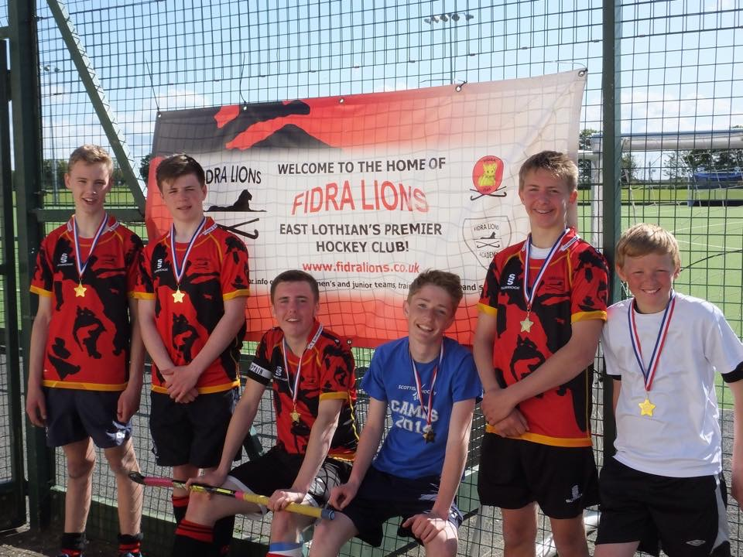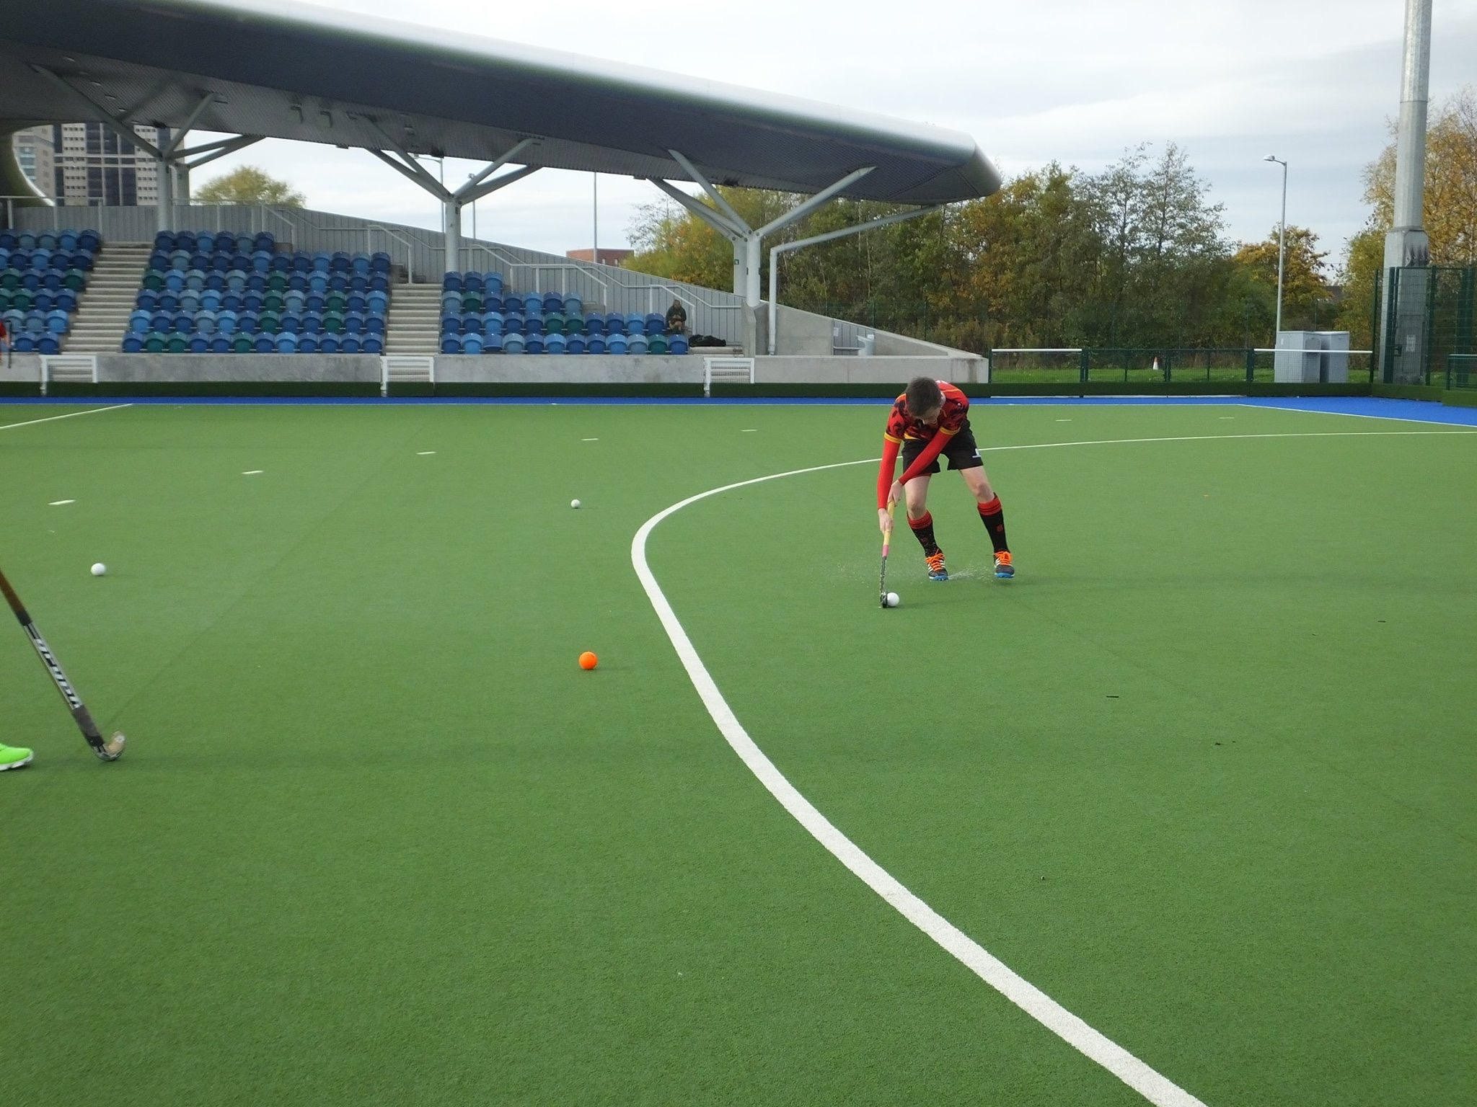

**U16 Boys Hockey**

**Wednesday Night**

**At Preston Lodge High School**

**6:30 to 7:30**

**Cost: Free**